Wat’s Going On?
Alan Brown M.A.
(Director of Archaeology)

The Caer Alyn Project is situated on the edge of the village of Llay, 3.8 km north of Wrexham. The core area of the project is a plateau of land surrounded on three sides by the River Alyn. This area includes an Iron Age inland promontory fort known as Caer Alyn (or Bryn Alyn Camp), which lies at the southern tip of the plateau, within a hairpin bend in the River Alyn (Fig 1).
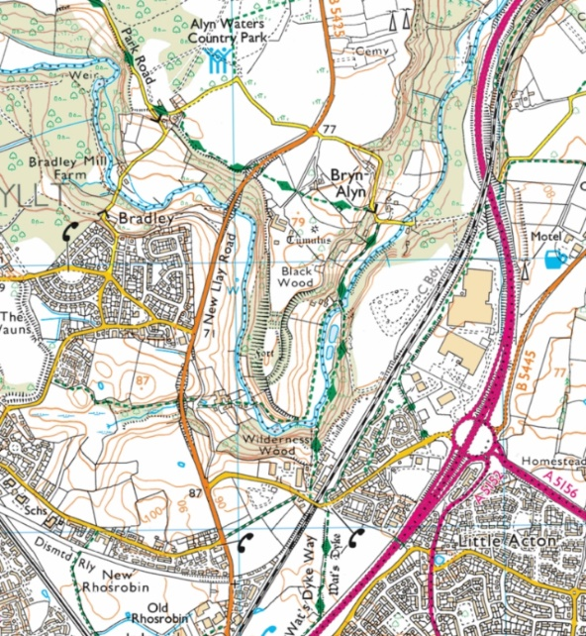

Fig 1. The location of the Caer Alyn Project. The line of the Wat’s Dyke Way is marked in green. Base map © Crown Copyright and database rights 2019 Ordnance Survey.
Sections of Wat’s Dyke have been located both to the north and south of the plateau and the most direct course between these points would be along the western edge of the Caer Alyn plateau and the fort (Fig 2).

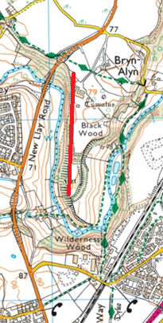v
Fig 2. Caer Alyn (Bryn Alyn) promontory fort. The red line shows the assumed course of Wat’s Dyke. Base map © Crown Copyright and database rights 2019 Ordnance Survey, with author’s own annotations.
There is possible evidence for the dyke at the southern end of the fort, where a depression leading up from the valley appears to be an entrance point into the fort. On the western side of this depression is a small bank and on the western side of that, facing into Wales, is what appears to be a shallow ditch.
This bank and ditch would seem to serve no defensive purpose, as immediately beyond them there is a very steep drop down into the Alyn valley. They might, though, be a section of Wat’s Dyke. However, this bank and ditch are within the fort’s scheduled area, so currently we cannot investigate them.

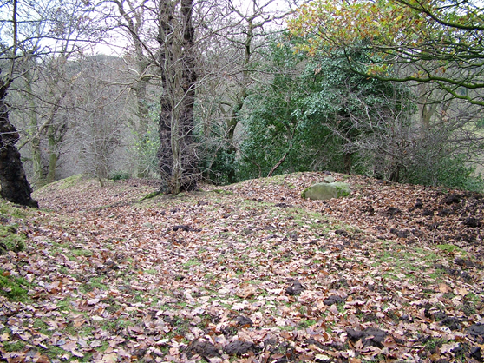
Fig 3. The path down from Caer Alyn’s southern entrance, with a possible section of bank on the right side of the picture.
However, the western edge of the Caer Alyn plateau to the north of the fort is unscheduled and no archaeological investigation has ever been undertaken on any part of it. We had intended to excavate a section of this area in August 2020 but due to the Covid-19 outbreak we may need to postpone this investigation.
In 2006 a geophysical survey was carried out in the area just north of the fort. Fourteen 20m grids were surveyed (Fig 4). The plot is complicated and includes a football pitch in the top left corner. The banks and ditches of the fort (presumed to be Iron Age) are situated just outside the survey area, to the south. The most outstanding anomalies in the survey are the semi-circular ditches running from east to west in the lower section of the plot. The biggest and deepest ditch is the northern one. This ditch seems to cross a linear feature (marked by the yellow line) on the western edge of the plateau: this is the assumed path of Wat’s Dyke. The plan is to put a trench in the area where both features cross, as indicated by the orange circle, with the aim being to ascertain if the linear feature is associated with the large cross ditch and/or with Wat’s Dyke. If this linear feature is associated with the dyke, it may also be possible to obtain dating evidence from it. The two cross ditches may indicate that the fort’s northern defences were reinforced at some point, possibly during the construction of the dyke or after its construction if the fort was being used as a defensible control point on the dyke.
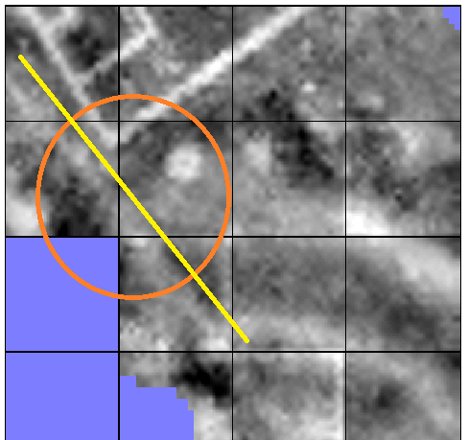

Fig 4. The results from the 2006 resistivity survey to the north of the fort.
In 2010 an excavation was carried out in a possible enclosure just below the southern entrance to the fort. The main trench excavated did not yield any significant finds or features. A second trench was opened on a linear feature that runs on a north-south trajectory through the valley, just below the enclosure. This earthwork is clearly visible on Lidar and had previously been identified from the 1843 Tithe Map and the 1879 1st edition OS map only as a field boundary (Fig 5).

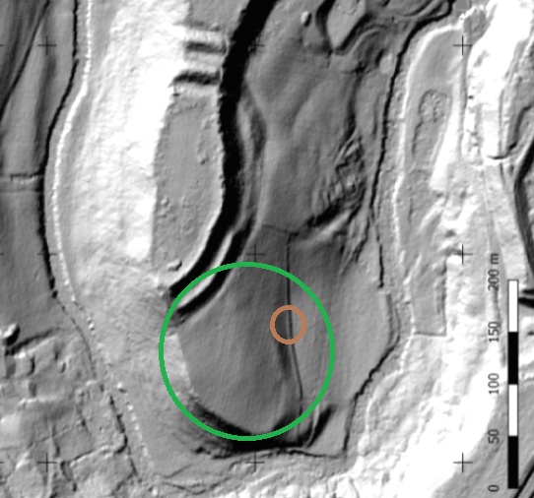
Fig 5. The southern end of the Caer Alyn hillfort. The green circle marks the southern enclosure, the area excavated in 2010. The brown circle indicates the position of the second trench, over the linear feature. Natural Resources Wales © Natural Resources Wales and database rights, with author’s own annotations.

The second trench was sterile with regards to finds, but it did reveal an interesting structure. At the time of the excavation, I was involved in training in the main trench, so was not involved in excavating the second trench. It wasn’t until later that I saw one of the photographs of the structure; a stone revetment with a ditch in front (Fig 6).

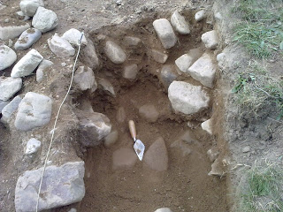

Fig 6. The stone revetment found in the 2010 summer dig. http://caeralynsummerdig2010.blogspot.com/2010/09/blog-post_7993.html

Field boundaries in this area are usually composed of hedges or trees (in 1879 the linear feature is recorded with trees running along its course). Stone tends to be used only for boundary walls around houses. This feature is therefore of great interest and it is the aim of the project to conduct further excavations to ascertain the date and function of this structure.
The bank at the back of this earthwork, which forms part of the southern enclosure (Fig 5) seems to indicate a line of deposition formed by the original course of the river. The flow direction of the river would support this. It has been proposed that areas along Offa’s and Wat’s Dykes were used to control movement and possibly trade between Wales and Mercia (Murrieta-Flores &Williams, 2017, p.98). Is it possible that the stone revetment at Caer Alyn formed a small dock for boats bringing goods out of Wales?
Caer Alyn may have been considered strategically important at the time of the dyke’s construction; a highly defensible point on the dyke that could be used for controlling the movement of people and/or goods. Further investigation and excavation may prove extremely exciting (virus restrictions allowing).
We are always looking for volunteers to join us. The Caer Alyn Project is situated on private land, so if you want to visit us, please email the group at caeralyn7@gmail.com

References
Murrieta-Flores, P & Williams, H. (2017) Placing the Pillar of Eliseg: Movement, visibility and memory in the Early Medieval Landscape. Medieval Archaeology, Vol 61, Issue 1, pp.69-103.

