Caer Alyn – A Brief History

The Caer Alyn Archaeological Project is situated on the edge of the village of Llai, 3.8 km north of Wrexham. The core area of the project is a plateau of land defined by the course of the River Alyn on three sides and on the fourth by the Llai New Road (B5425) and Pont-y-Capel Lane. The plateau today contains several small complexes of residential buildings surrounded by pastureland.

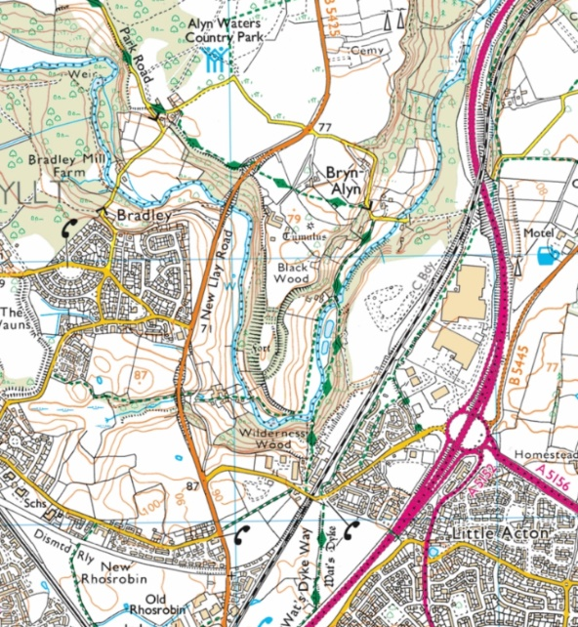

Fig 1. The location of the Caer Alyn Project. The line marked in green is the path of the Wat’s Dyke Way. Base map © Crown Copyright and database rights 2019 Ordnance Survey.

The oldest archaeological feature at Caer Alyn is the Bryn Alyn round barrow, a scheduled monument that is believed to be the remains of a burial mound from the Bronze Age (c.2,500 – c.800 BC).

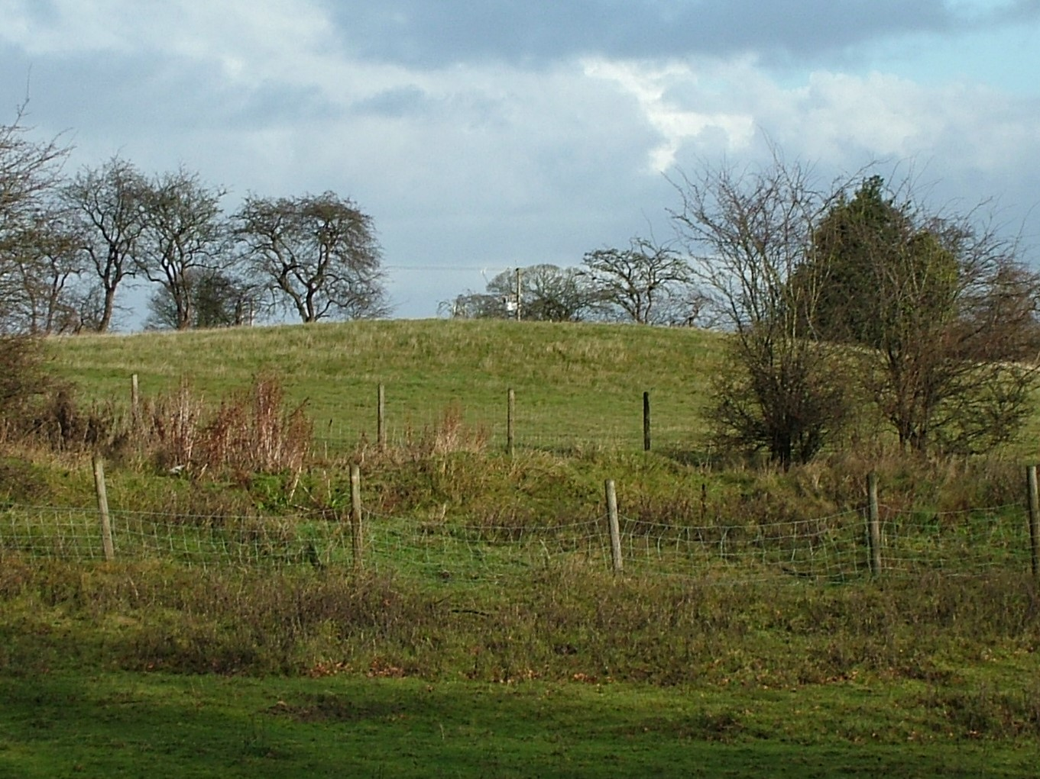

Fig 2. The Bryn Alyn round barrow.

However, the dominant archaeological presence on the site, and the one that gives the project its name, is Caer Alyn (or Bryn Alyn Camp), an inland promontory fort which lies at the southern tip of the plateau, within a hairpin bend in the River Alyn. Although small, Caer Alyn has impressive defences, both natural and man-made. It too is a scheduled monument and has been dated to the Iron Age (c.800 BC - 43 AD) based on the evidence of its banks and ditches.

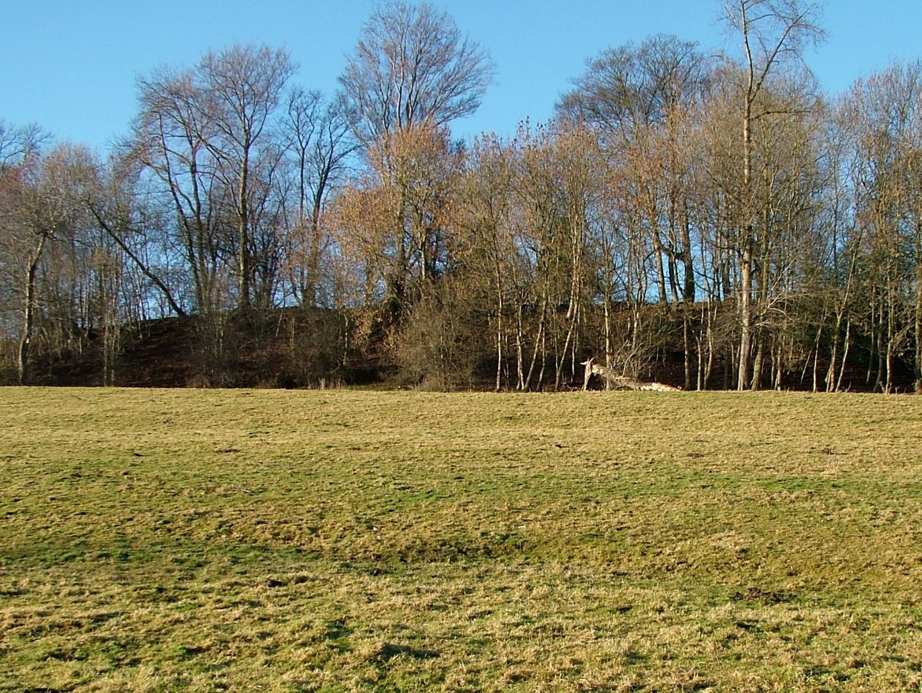

Fig 3. Caer Alyn (Bryn Alyn Camp) as seen from the river valley to the east.

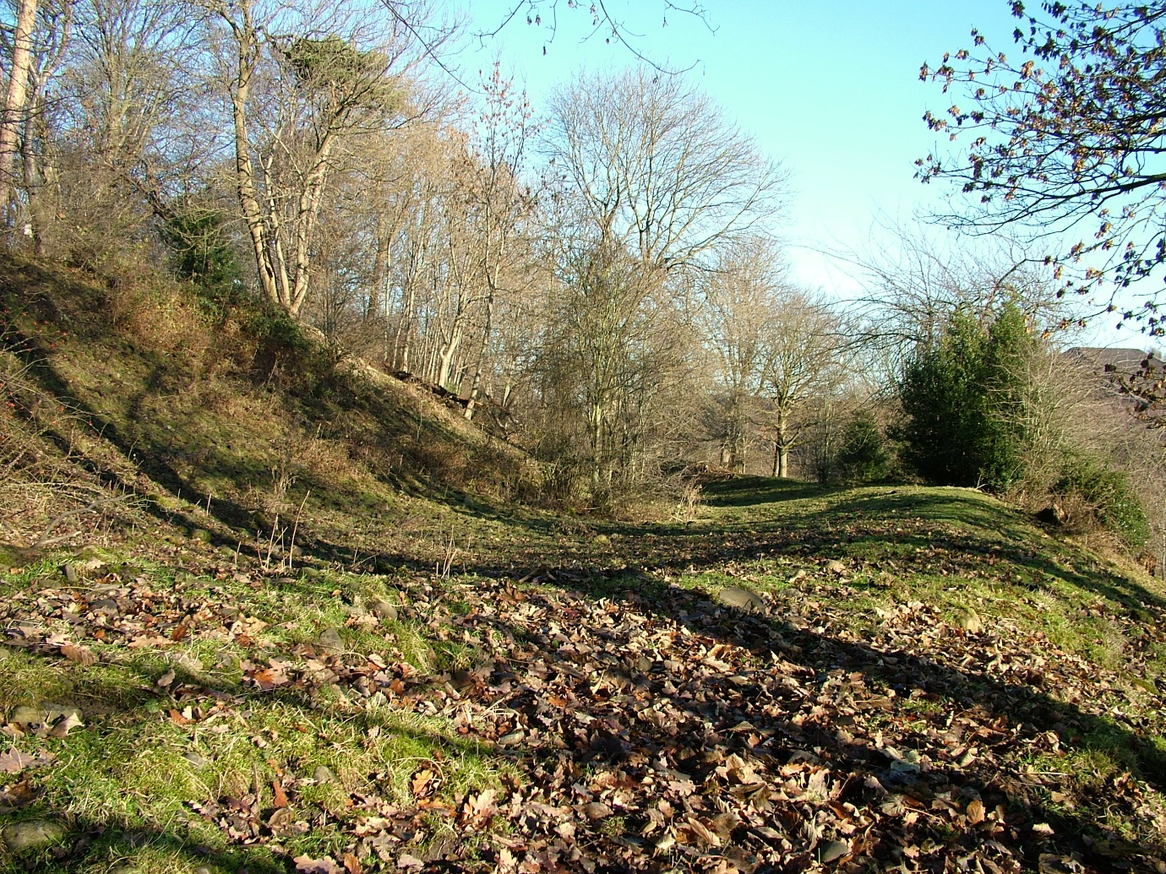

Fig 4. The ramparts on the eastern side of the fort.

There is the possibility that Caer Alyn was also utilised centuries later, in the early medieval period, as part of the border defences between Wales and Mercia. Sections of Wat’s Dyke, the linear earthwork that runs through the northern Welsh Marches, have been located both to the immediate north and south of the plateau and the most direct course between these points would be along the western edge of the plateau and the fort.

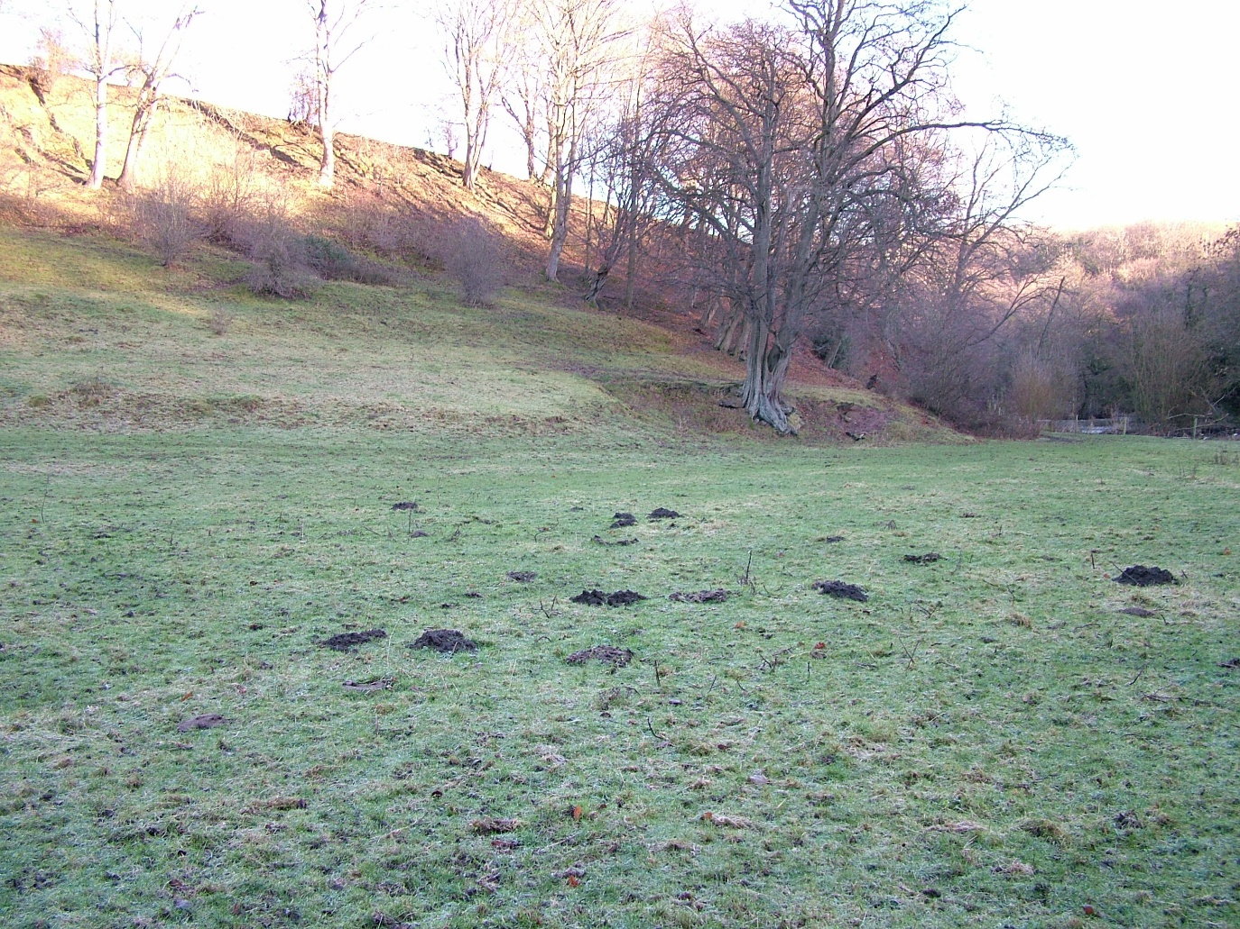

Fig 5. The western slope of the hillfort, as seen from the river valley. The top of the ridge is the possible route of Wat’s Dyke.

Other features of interest on the plateau include Bryn Alyn, a Grade II listed house believed to date from the turn of the nineteenth century, and Bryn Alyn Wall and Ditch, a low circular retaining wall and filled-in ditch that lie between the modern Alyn Lodge and Blackley Hall, a building with late eighteenth-century origins. The wall and ditch have not been firmly dated and are perhaps a garden feature from the eighteenth or nineteenth century, but there is a possibility that they may be medieval.

The valley of the River Alyn, surrounding the Caer Alyn plateau and the fort, is also a focus of historical interest, containing as it does several old farms, mills and bridges.

Written sources, field and place names suggest that the missing medieval chapel of St. Leonard’s de Glyn lay close to the Caer Alyn plateau, and more sites of archaeological and historical interest are being revealed by the work of the project.

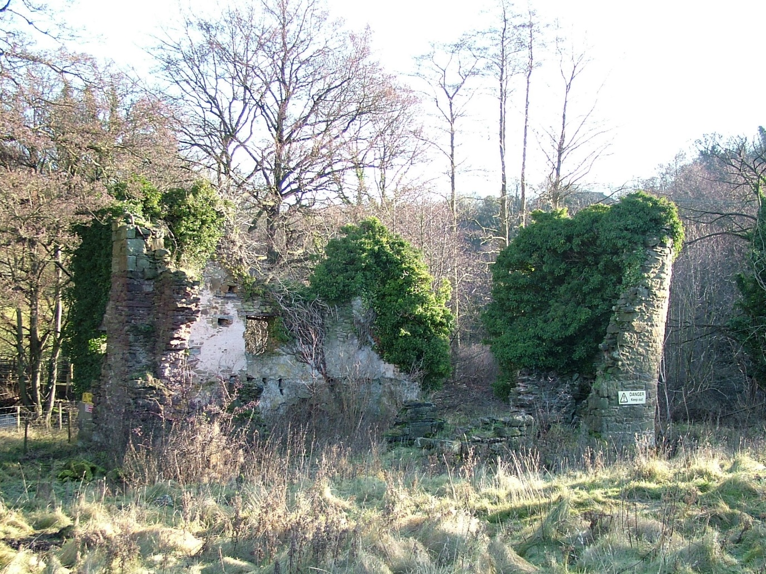

Fig 6. The ruins of Gwersyllt Mill, on the banks of the River Alyn.
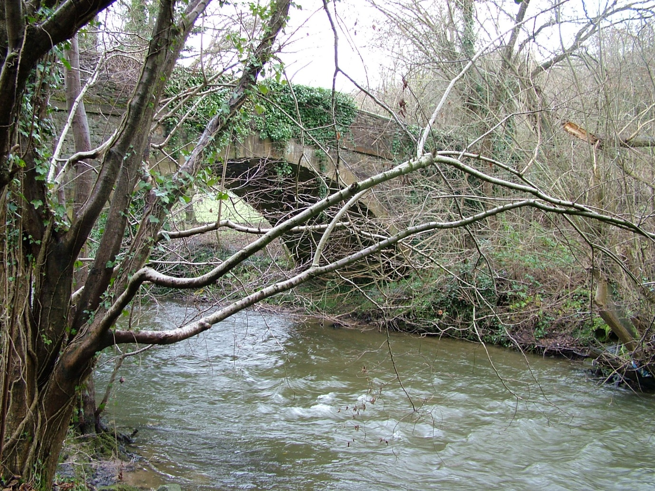

Fig 7. The bridge over the River Alyn at Pont-y-Capel.

